Case example: “CxG development of shared context enabling parents to create a holding Space for their children on a family holiday “

1. Background

Patrick Humphreys was born in 1945 as the only child born to Mollie and Darlow Humphreys. The family home was located in Frome, Somerset (a small town in the south of England). Both parents were Academics: Mollie ran the History Department at Bath Spa University and Darlow directed the Department of Education at the University of Bristol. As both parents were employed away from home most days, Patrick was looked after at home by a young live-in nanny and her mother (Patrick’s godmother), who lived nearby.

Each year, at Darlow’s request, Darlow and Mollie travelled from their home in Frome to take a 3-week holiday in an exotic location together as a couple. During that time, Patrick was left behind at home under the care of his live-in Nanny together with his godmother

When Patrick was four years old, his parents bought a house in Bath, and Mollie, Darlow and Patrick moved to Bath a city that was nearer to where his parents were employed But Patrick’s Nanny and Godmother remained in Frome. Darlow employed a series of part-time live-in au-pairs to look after Patrick alone at home when Mollie and Darlow were away at work.

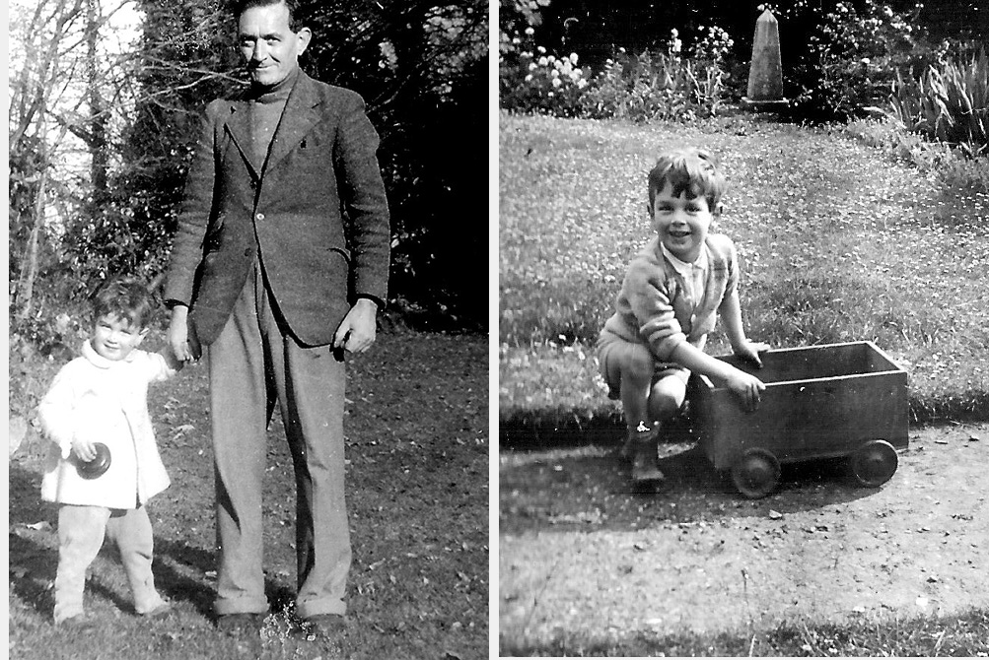
In Frome, 1947, with Darlow < Patrick in garden at home> In Bath, 1950.

At weekends, Mollie established the garden at Sion Hill as a holding environment where Patrick could play with Buffy Leach, who was the same age as him and the only child of the Leach family who were neighbours at Sion Hill. Patrick enjoyed playing together with Buffy in this holding environment but their relationship as good friends did not develop into being childhood anam caras.

Patrick talked about anam cara relationships with Mollie: she told him details of her own relation relationship with her lifelong Anam cara Jymmie. Patrick told Mollie: “I enjoy playing with Buffy, but she is not my anam cara. I would love to have an aman cara relationship like yours. Mollie replied: “parents can find and provide ‘’holding environments’’ that help the development of anam cara relationships, but finding and developing an anam cara relationship is something that you have to do for yourselves: communicating with each other about anything and everything without any boundaries between the two of you.

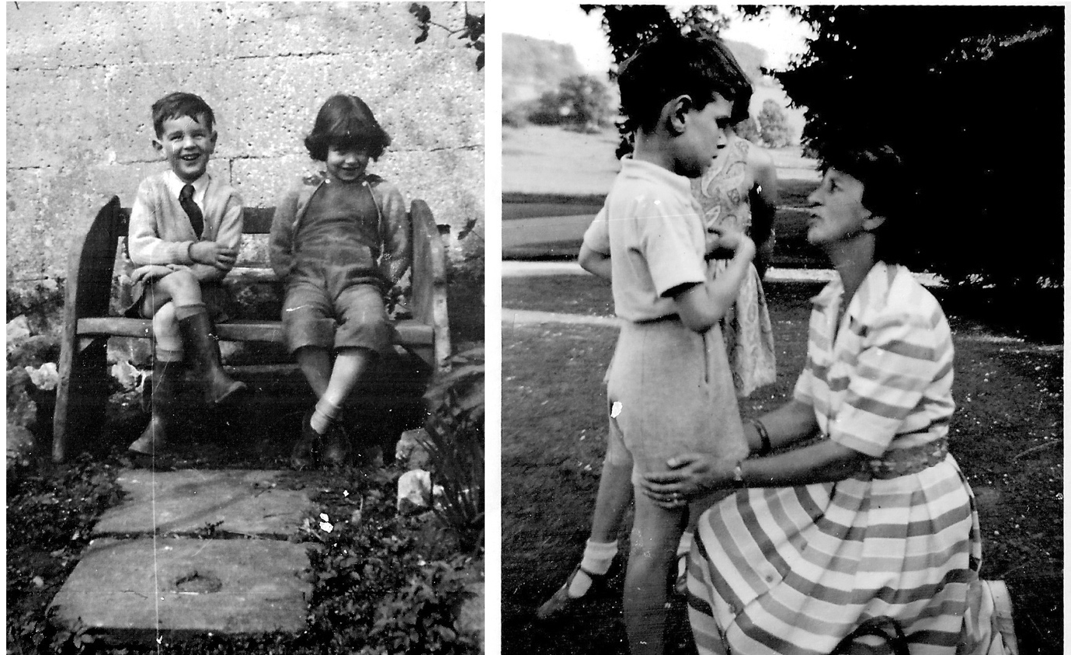
Patrick and Buffy in holding environment at Sion Hill : Mollie explains anam cara relationships to Patrick

2. Modelling actor activity at the conceptual level: Mollie’s Holiday decision problem

When they lived in Frome, ach year, at Darlow’s insistence, Darlow and Mollie had travelled from their home in Frome to take a to take a 3-week holiday in an exotic location together as a couple. During that time, Patrick was left behind at home under the care of his live-in Nanny together with her mother, were able to arrange and implement a successful holding environment at home in Frome.

But after the family moved to Bath, Darlow wanted to continue the annual practice of “taking a 3-week summer holiday in an exotic location together as a couple.” But during the period that his parents were away on their summer holiday, Patrick could no longer be looked after at home by familiar and trusted people (like his previous nanny and godmother in Frome), who could establish a n effective holding environment for him at home in Bath, so Mollie had to find a way to solve this problem that would be satisfactory for Patrick.

She tried adopting a “rational choice” approach (Simon, 1979): for the contextual element (CE): “Evaluate various alternative care arrangements for Patrick for the period that Darlow and I are away on holiday”, Instantiated as CE’: Employ a temporary live-in professional carer; and CE’’: Send Patrick to a residential Activity Camp for children his age; etc.). But none of these instantiations seemed to be satisfactory in cost-benefit terms. So Mollie was left feeling "adrift in a sea of Rational Choice uncertainty" about how solve her problem in a way that would for all members her family (i.e., Mollie; Darlow and Patrick)

Mollie was now stuck in a decision trap because she needed to implement both of two linked actions that she now realized were incompatible with each other. In order to escape from this conundrum, Mollie needed a new shared context for the activities involved in “taking our summer holiday”:

3. Modelling actor activity at the Operational level: Mollie’s need to “Find a new context for “taking summer holiday and implement activities within in that context that solve my problem”

So, Mollie contacted her own lifelong Anam Cara (Jymmie and asked her "what should I do to overcome this Conundrum"? Jymmie investigated Mollie’s conundrum with her and then then explained that they need to share the contexual element (CE-1) Enjoy an adults-only holiday, with Darlow and implement a care strategy that keeps Patrick happy while his parents are away on holiday without him are incompatible” and do something as a result.

Then Jymmie introduced a concealed conceptual element (CE-2) to Mollie by telling her: “You and Darlow are academics with relatively long summer holidays. Recently, you have spent 3 weeks each summer on travelling as a couple to adult-centred resorts where you enjoyed walking, rest and recreational activities together, but you left Patrick at home at this time. Perhaps in future you should take your 'three-weeks-away summer holiday' each year as a family holiday with Patrick that would provide the opportunity for Patrick to find and develop a relationship with hi` own childhood anam cara (soul friend). As a result, you, Darlow and Patrick would be able to enjoy living together in a unified world, receiving positive affirmation from each other, and thus restoring your own self-love”.

Mollie said to Jymmie "That seems good, but I do not know I could actually escape from my conundrum by arranging a “really successful Family holiday in practice” (i.e., Mollie has no experience of doing this and so cannot presently conceptualise an implementation of CE-2 in her working context.) Thus, Mollie needed Jymmie to provide an implementation idea CE’-2) in order to extend their shared context.

Jymmie said to Mollie "Well, I have a practical idea for you. I know of a small guest house, called Sunny Ridge near where I live in Devon, run by the Brewster family, it is located close to Bantham, a lovely secluded beach edged by low cliffs with tiny coves that provide shelter in windy weather. The coves lie behind a shallow sandy beach with pools and rocky outcrops appearing as the tide goes out. Sunny Ridge has a very loyal clientele, with families from many parts of England returning there summer after summer to Bantham beach where these families form ad-hoc groups together in various combinations and eat picnic lunches provided by Mrs Brewster. If you were to book your three-week summer holiday at Sunny Ridge, you would gain a very good opportunity to create your family holiday in association with the other families from Sunny Ridge who picnic there."

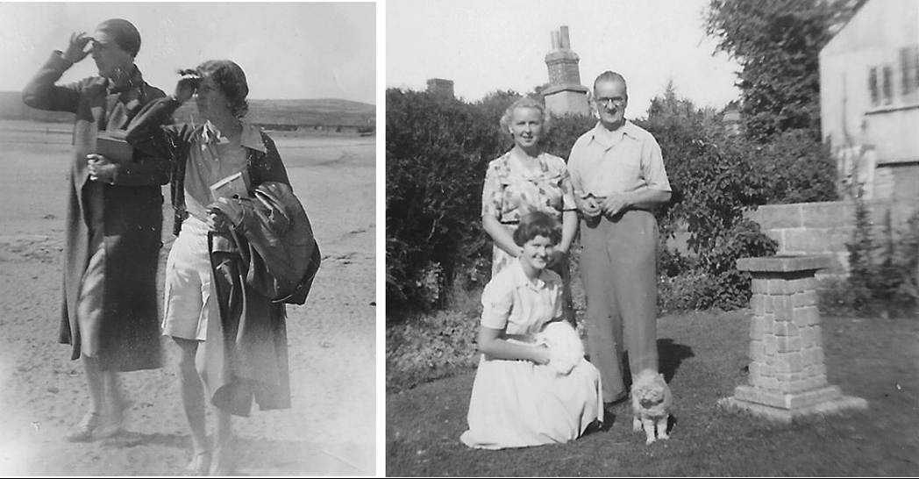
AnamCaras Jymmie & Mollie, Devon, 1935. The Brewster Family in Sunny Ridge's garden, Devon,1952

So, Mollie agreed with Jymmie on how to implement the now-shared contextual element and initiates the proceduralization of this new context by securing a 3-week family booking for Mollie, Darlow and Patrick at Sunny Ridge in July 1952.

In this way, anamcara seeker-provider interactions between Mollie and Jymmie enriched the shared context that could enable a “Successful family holiday with Patrick”

4. Actor activity Modelling at the implementation level: CxG Proceduralisation of a shared context for ”Book family holiday at Sunny Ridge

As represented in Figure 1 (below), Actors Jymmie (A1) and Mollie (A2) work within a shared context where Mollie ‘s mental representation within contextual element CE-1of ” “enjoy an adults-only holiday with Darlow” (CE’-1) is incompatible with her mental representation of “implement a care strategy that keeps Patrick happy while his parents are away on holiday without him (CE’’-1)
Because of this, Jymmie (A1) proposes the instantiation CE’-2 Arrange a family holiday for Mollie, Darlow and Patrick at Sunny Ridge Guest House next summer.
Once both A1 and A2 agree on CE-2, a proceduralized context can be developed for the action “Book family Holiday at Sunny Ridge for July, !952” (CE-3)

Take a family holiday where you, Darlow and Patick where you can enjoy yourselves and collaborate with a family in experienced in buiding a holding environment successfully for their chiden. Because of this, result, A1: Jymmie then proposes the instantiations CE’-2 take a family holiday for Mollie, Darlow and Patrick at Sunny Ridge Guest House next summer and (CE’’-2) buicvreabuimplrement a ghodin Environmnt at Bantham beach with a family saying at sumnny ridge. ride wit eperiebnce of doing thhis
One both A1 and A2 agree on CE-2, a proceduralized context can be developed for the action “Book family Holiday at Sunny Ridge for July, !952” (CE-3)

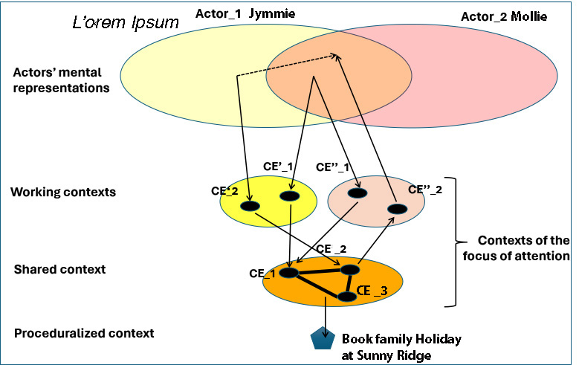

Figure 1: Building the proceduralized context for “family Holiday with Patrick in a newly shared context

When staying as a family at Sunny Ridge in July 1952, Mollie, Darlow and Patrick aimed to spend much of their time as a family on Bantham Beach, picnicking together with the Baron family (parents Barbara and George and their children. There Patrick met Nancy Baron, (age 7) and her elder sister Rosalind. (age 10). Patrick was very keen to play with Nancy and Rosalind and to develop an anam cara relationship with Nancy Baron. Nancy reciprocated (see Picture 1)

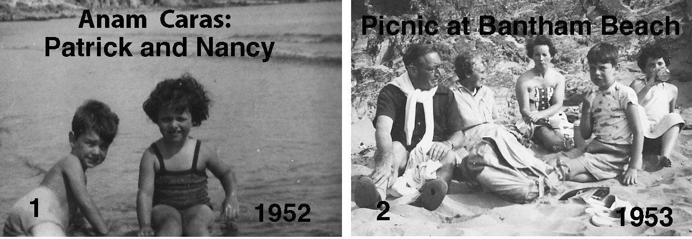

Note that Patrick was lucky (or perhaps fated) to find his future anam cara Nancy at Bantham beach. The success of Patrick and Nancy’s meeting there could not be pre-arranged by Mollie (A2) who only arranged the Opportunity for this development to occur at Bantham beach

As a result, the Humphreys and Baron families arranged that both families would stay at Sunny Ridge for the same 3-week period in July 1953., so that they could again picnic together in a safe holding environment at Bantham beach, which would please the children in their families (see Picture 2) and also support the maintenance and development of Patrick and Nancy’s anam cara relationship .

5. “Family Holiday” Interlude: Summer 1954

In January 1954 Darlow decided that he wanted to have a summer family holiday with Mollie and Patrick, staying at a a lakeside hotel in Thun, Switzerland. There, Patrick, Mollie and Darlow travelled together on heritage lake paddle-steamers and mountain railways. But Patrick missed very much having the opportunity to experience all this in the company of his anam cara Nancy. He begged his parents to arrange a Family Holiday at Sunny Ridge next year, when Nancy would be there too.

Mollie arranged with Barbara Baron that the two families would meet together at Sunny Ridge for three weeks in July 1955. Mollie promised Patrick that, on that holiday, both families would spend time together picnicking at Bantham Beach.

6 Actor Activity Modelling at the environmental Level: Accessing a holding environment plus creative a implementation of a Holding space facilitating the development t of anam cara relationships

Mollie was still puzzled about why Picnicking at Bantham beach in particular was so attractive to Patrick, while there were several nice beaches close to Sunny Ridge, that appeared to constitute good holding environments( see map below). So, she contacted Barbara (A6) and asked her if she knew why picnicking at Bantham beach was so special for Patrick and Nancy.

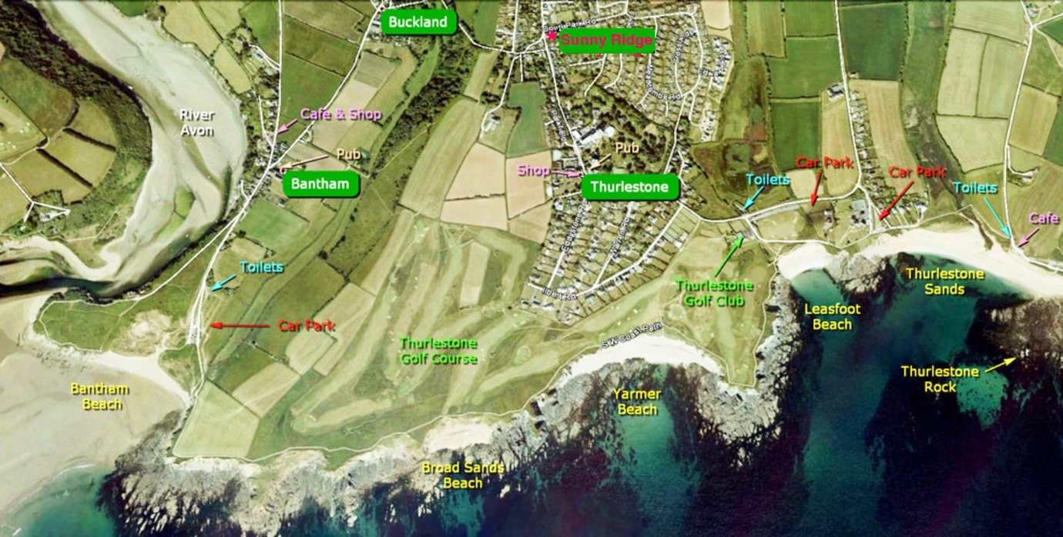

Barbara explained to Mollie that there were two linked contextual elements underlying its attraction to the families’ children. The first contextual element (CE-5) is that Bantham Beach’s environment has physical and social aspects that combine to offer a good holding environment

At the Enironmental level, Bantham Beach has very good potential: It is secluded beach edged by low cliffs with tiny coves that provide shelter and privacy families and privacy for families picnicking within them (see Picture 2, above). The coves open to a large shallow sandy beach with natural paddling pool pools and rocky outcrops appearing as the tide goes out. This local environment is pleasant and safe for children to explore.

The second contextual element is that I have some success in building on proceduralising “family holiday in a safe holding environment at Bantham beach” to include the creative implementation of a “Holding Space” for our children’s activities there. I needed to construct and maintain a holding space that would allow them to test the autonomy while experiencing being psychologically held,”. Our children now have the opportunity (with support and encouragement from their parents) to develop anam cara relations with each other, if they wish to do so.

In order to create and maintain a Holding Space, it is necessary for a parent
- To listen rather than advise.
- To be with rather than make better.
- To offer myself rather than impose myself.
- To accept where my child is at any moment and to be with that moment – and where
- I am - at the same time.
- Not to worry about what a particular mood or situation might mean for me or us; just aim to keep the situation safe, creative and free.

Perhaps, in the future, when we are at Bantham beach with our children, you and I should work together to construct a holding space for them? Mollie agreed.

Thus, Mollie and Barbara decided to implement the now-shared context “Create a Holding Space together when next at Bantham Beach with our families” so that “family holiday” could work out successfully (but differently) for the participant parents and children.

FiIn July, 1955, Patrick and Nancy, were active in developing their anam cara relationship within the holding space that Barbara and Mollie created at Bantham beach. They were now each 10 years old and sought more independence for developing anam-cara-related interactions, while their parents shared the holding space agent tasks: involving safeguarding and observation, without invasion, direction or control (see picture 3, below).

Some of Patrick, Nancy and Rosalind's anam-cara-related activities are shown in Pictures 4-6, below. Barbara Baron is acting as the agent creating and maintaining a holding space in accord with Winnicott’s (2006) notion of a "safe space that “allows an individual to test autonomy while being psychologically held"

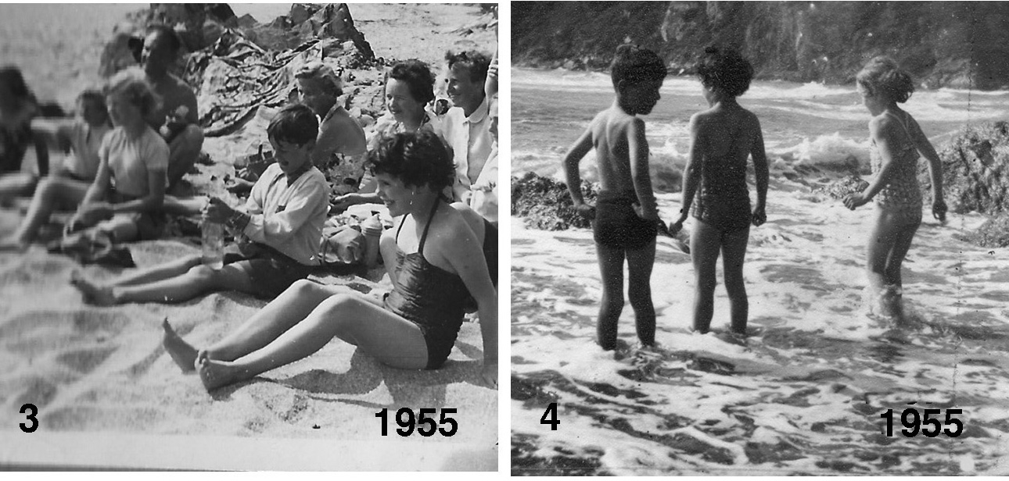

3. Parents safeguarding and observation, without invasion, direction or control.
4: Patrick Humphreys with his anam cara Nancy and her sister Rosalind challenging the waves.

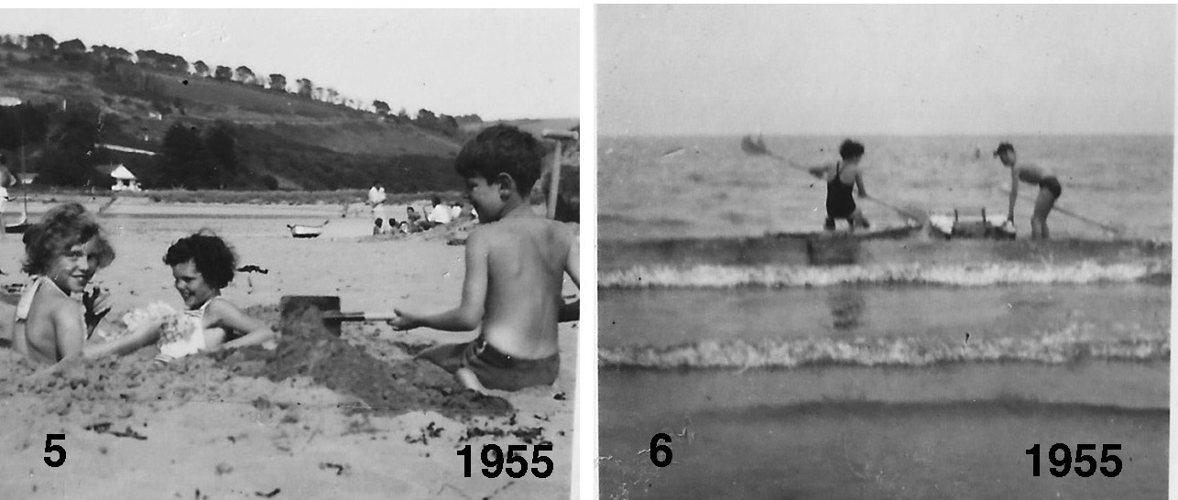

5: Patrick offering Nancy and Rosalind a ride in the sand-boat that he had built for them
6: Patrick and his anam cara Nancy confront the waves at Bantham beach with their paddle boards.

This complete "holding space creation and maintenance" system worked out very successfully, particularly as Bantham beach's physical geography itself provided a good holding environment.

